Fall HOURS

Tuesday - Wednesday 10:30 A.M – 2 P.M
Thursday, Friday
10:30 A.M. – 8 P.M
Saturday 10:30 A.M. – 6 P.M
OR UNTIL WE SELL OUT OF
BREAD
CLOSED ON SUNDAY
& MONDAY
TOPPINGS:
LETTUCE
TOMATO
ONION
BLACK OLIVES
JALAPENOS
BANANA PEPPERS
BELL PEPPERS
CHEESE:
AMERICAN
SWISS
PROVOLONE
PEPPER JACK
Hot Rod Subs
5787 US Hwy 43
Gu-Win, Alabama 35563
Phone (205) 468-2666

http://www.hotrodsubs.com
Party Trays Available for all occasions
(Must be ordered one day in advance)

Our Subs are made fresh with Love. It takes

time to prepare your food this way so please

be patient.

This is NOT a “fast food” restaurant.
Menu
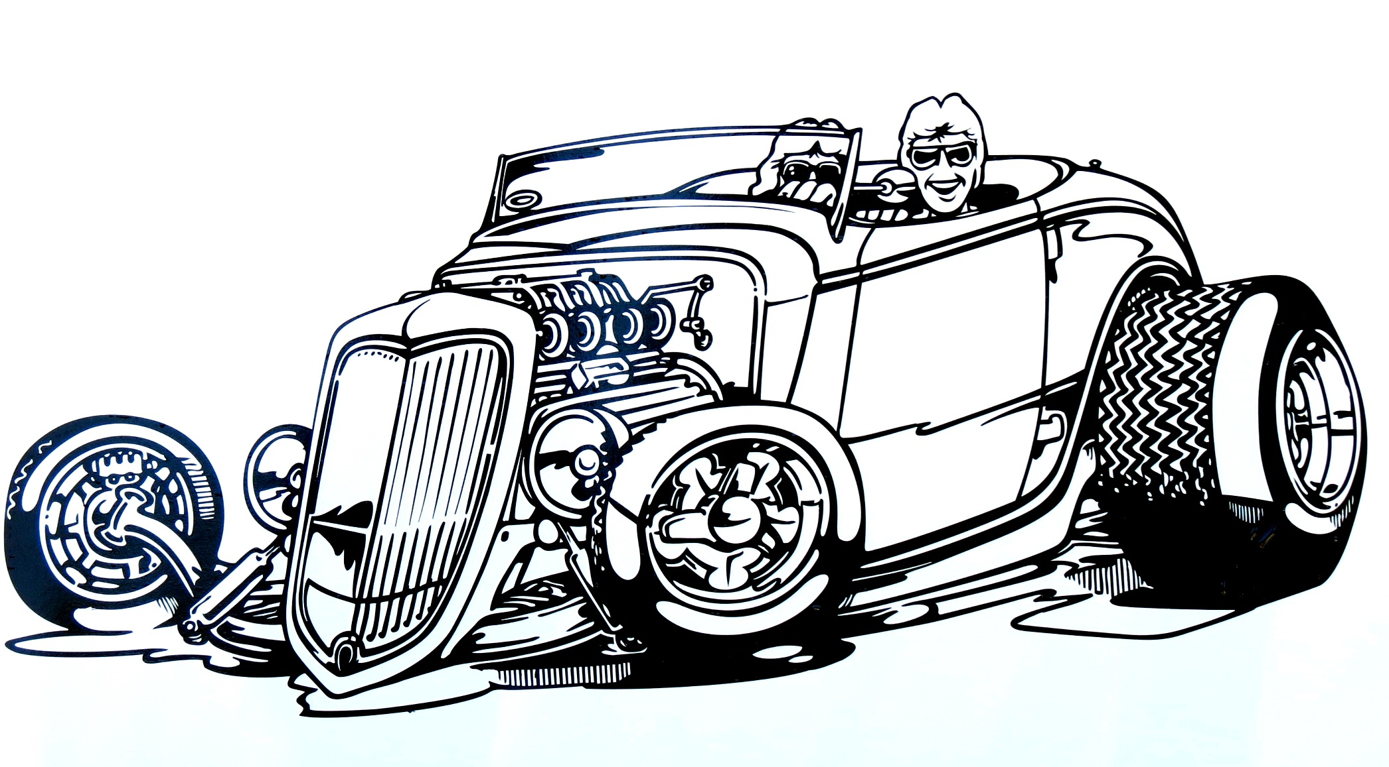
David & Dotty’s
Hot Rod Subs
Best Sandwich Shop
In
Gu-Win

Roast Beef Sub
Melt in your mouth Roast Beef piled high on $6.75
Either white or wheat rolls, your choice of cheese
And toppings.

French Dip $6.95
Roast Beef stacked high, topped with Swiss
Cheese on grilled white bread with a side
Of Au Jus for dipping.

Pastrami

Pastrami steamed to perfection topped with $6.95

Swiss cheese, Special Dressing

Turkey Sub
Succulent white Turkey Breast on your choice of $6.75
Bread, cheese and toppings.

Ham Sub
Ham piled high on a fresh baked roll, your $6.50
Choice of cheese and toppings.

Italian Sub
Ham, salami and provolone cheese on $6.50
White or wheat roll with your choice
Of toppings.

Melt Down
Turkey, ham, and bacon on white or wheat $6.75
Roll, your choice of cheese and toppings.

Hot Rod Club
Roast Beef, Turkey, Ham and Bacon, piled $6.95
High on your choice of bread and cheese.

Home of The

Monster Meatball Sub
Delicious Italian Meatballs on our fresh baked $6.95
Sub Roll with your choice of cheese.

Reuben
Corned Beef on Rye bread, covered in $6.75
Sauerkraut and Swiss cheese, Special
Dressing and heated to Perfection.

Rachel

Turkey on Rye bread,covered in $6.75
Sauerkraut and Swiss cheese, Special

Dressing and heated to Perfection.

Kids Meal
½ Sandwich on white bread, your choice of $4.50
Single meat(ham, turkey or roast beef) your
Choice of cheese, served with chips and a cookie.

BLT/Veggie Sub $5.00

Grilled Cheese $4.25

Chef Salad
Fresh bed of lettuce topped with tomato, onion $6.50

Turkey, ham, and cheese.

Extra Meat $1.00

Extra Cheese $0.75

Add/Extra Bacon $1.00

All Subs Served With Chips and a Pickle.

